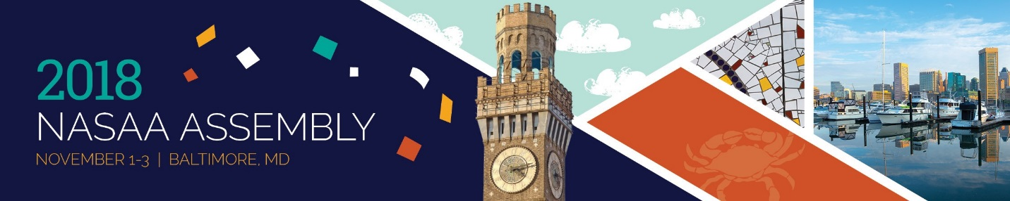
Folk & Traditional Arts Coordinators Peer Session
November 1, 2018
3:00 – 5:00 p.m.

Agenda

3:00 – 5:00 p.m. Partnerships Panel Discussion
State folk arts staff are increasingly expected to look for ways to collaborate with like-minded organizations or those whose missions, programs or constituencies overlap with those of the state arts agency. A panel comprising representatives of several long-standing partnership based programs, as well as those of programs that have had little or no involvement with such collaborations, discuss their experiences and the capacity required to initiate and sustain partnership projects and programs. Special attention is given to collaborating with mission-driven organizations, the impact of funding cycles on programming and staff capacity, and the professional expertise required to manage a network.

Contact the Folk and Traditional Arts Peer Session coordinators with questions or feedback:

Patricia Atkinson, Nevada Arts Council
Chad Buterbaugh, Maryland State Arts Council
Jon Kay, Traditional Arts Indiana
Amy Kitchener, Alliance for California Traditional Arts
Cheryl Schiele, National Endowment for the Arts

